April 6th, 2017

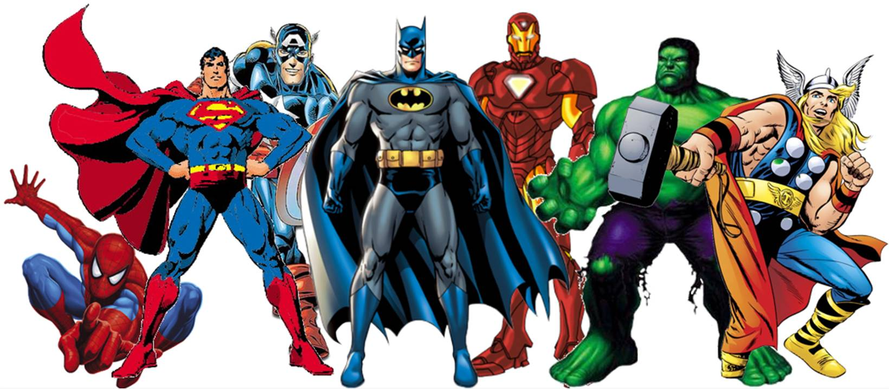
Inside SUPERHERO FIELD DAY 2017

Created by: Jimmy Grassano
Inside Field Day 2017 Schedule

Rotation 1: 8:50-10:05

Rotation 2: 10:15-11:30

Lunch: 11:40-1:20

Rotation 3: 1:30-2:45

Closing Ceremony: 2:45-3:00

Please have students packed up before Rotation 3 begins!
Remember, with us being inside I had to use the entire building to pull this off. Please keep safety in mind and if your students are getting too wild please stop them and remind them we are inside. It is better than nothing!
Thanks!

Center 1: Gym and Fine Arts Hallway

Station 1: Race to the Hall of Justice (Gym)
Each squad will go to their volleyball standard. Two students will race at the pole. They will sit on the carpet square and grab the rope. The next student in line is the referee. They will say, “Ready, set, go!” The two students pull the rope to make it to the pole first. Winner stays on.

Equipment: 4 volleyball standards, ropes, 8 carpet squares

Station 2: Invisible Volleyball (Gym)
Mats will be set up to make the volleyball game invisible. Superheroes have super powers to see through things. Have class play invisible volleyball. Use rally scoring for this activity. Play until it is time to switch.

Equipment: Mats, beach ball

Station 3: Ninja Turtle Pizza Box Relay (Gym)
Students will be in squads and line up behind their cone. On a signal race through a cone course (zig-zag) with pizza boxes in their hand (do not help keep them up with any other body part). Students have to jump over a hurdle and then return to their team weaving through the cones, hand the boxes to next person to go.

Equipment: pizza boxes, cones, hurdles

Station 4: Ant Man Scooter Relay (Gym)
Students will be in their squads behind a scooter. They are Ant Man so they must sit on their scooter and go through the obstacle course. Students will go down and back and pass their scooter to the next person in line. First squad done wins. Make sure scooter has wheels facing up whenever it is not being used for safety.
Equipment: 4 scooters, cones, hoops

Station 5: Superhero Theme Song (Music Room)
The class will be in Ms. Girard’s room and they will use her musical instruments that she has selected for the class. They will follow along to the board and create their class superhero theme song.
Equipment: Musical Instruments

Station 6: Flying Superhero Mobile (Science Room)
The class will be in the Science room and use their imagination to create their own flying superhero mobile (paper airplane). Once complete they can test fly it where the teacher allows them (hallway could be an option).
Equipment: paper

Station 7: Superhero Creation (Art Room)
A class will be in Mrs. Gerek’s room to draw their favorite superhero or create their own.
Equipment: Art supplies, paper

Station 8: Hawkeye Throw (Hallway)
Divide the class into 3-4 groups. Each person will take a turn throwing the javelin from behind the throwing line. The furthest throw from each group is the winner and can challenge other winners. Each person should try to improve their throw each time.

Equipment: 6 noodles, 6 polyspots

Center 2: Library/Hallway Classrooms in Middle of Building

Station 1: Chinese Spider Man Jump Rope (HALLWAY BY HINTON’S ROOM)
Students will make groups of 3-4 and use the Chinese Jump Rope. There will be a superhero pattern for them to complete.

Equipment: Chinese jump ropes, pattern sheets

Station 2: Superhero Rock/Paper/Scissors (POPP’S ROOM #19)
A class will be in Mr. Popp’s room and will play “Aerobic Superhero Rock/Paper/Scissors.” Your students should know how to play aerobic rock/paper/scissors. If your class does not remember please ask a PE teacher to review it. When a student wins they get a point. Whoever gets the most points is the “superhero” of the class!
Equipment: Mr. Popp’s classroom

Station 3: Captain America Shield Hula Hoop Skills (4th GRADE HALLWAY)
Students will hula hoop with Captain America’s Shield. Show off your hula hoop skills and take turns with your partners.
Equipment: Hula Hoops

Station 4: Comic Book Cover (COMPUTER LAB)
A class will be in the computer lab and will use Wixi to create a Comic Book cover. Mrs. Harrison will have directions in the lab for teachers. Students do not need to logout when done and will not print or save their work.
Equipment: Computer Lab

Station 5: Superhero Book Story (LIBRARY)
A class will be in the library and sit at the tables for their teacher to read them a story. Mrs. Dibbs will have a few choices for you to read to your class.
Equipment: Mrs. Dibb’s books
Station 6: Mrs. Hoggard’s Design Stations (HOGGARD’S ROOM #1)
Students will complete the stations Mrs. Hoggard has created!
Equipment: Mrs. Hoggard’s materials

Station 7: Guardians of the Galaxy Dance Off (ARMITAGE’S ROOM #2)
The SMART Board will be set up for students to dance along with. I will provide a list of songs that you can play for your class to dance along with. Superheroes love to show off their dance moves!
Equipment: Projector, Music, Armitage’s Room

Station 8: Incredible Hippity Hop Relay ( 2nd Grade HALLWAY)
Relay Race. Students form 3-4 teams and hop from one side to the other and back. First team back wins.
Equipment: hippity hops, polyspots, cones

Center 3: Cafeteria/Stage/Foyer

Station 1: Superhero Parachute (STAGE)
A parachute will be set up for students to do different activities with. They can make waves, pop the objects up into the air, make a dome to “hide” in, climb the mountain. Switch it up for your class to have fun!
Equipment: parachute, nerf balls

Station 2: Wolverine Relay
Divide students into squads. Each squad will have a paddle and each squad will have a ball. On the signal, one student will balance the ball, while moving quickly down the track. They will pass the ball to the other student when they return. When each student has had a turn, the team that is sitting cross legged on their bottom is the winning group. Have younger groups balance the ball on the paddle. Have the older students bounce the ball as they move.

Equipment: 4 paddles, 4 tennis balls, p0lyspots, cones

Station 3: Wonder Woman Hula Hut Knockdown
Students will be in their squads. Each squad will have a set of 6 hula hoops. They will run down and create their hula hut. Once the hula hut is complete they will run back and try to throw their ball to knock it down. First squad to knock it down wins. Play again until it is time to rotate.
Equipment: 24 hula hoops, polyspots, 4 gator balls

Station 4: Ice Cream Cone Relay
Even superheroes need ice cream to reward themselves! Students will be in their squads behind the cones. Each person will put the ball in the cone to make an ice cream cone. They will run through the cones in a zig-zag pattern and then hand the cone to their teammate. First team back wins. Continue to play until time to rotate.
Equipment: cones, 4 gator balls, polyspots

Station 5: Phone Booth Relay
Every superhero needs to hide their identity. Students will be in their squads split at both ends of the cones (half of the squad at one cone and the other half at the other cone). One student will run down and put the pants, shirt, glasses, and hat on. They will then run to their cone and take off those clothes. The next person will put the clothes on and run to their other side. Continue until everyone has had a chance to put the clothes on and take them off. First squad done wins. Continue until time to rotate.
Equipment: 4 sets of clothes, ployspots, hula hoops

Station 6: Bottle Cap Superhero Creation
Students will be with their squads at a hula hoop full of bottle caps. They will use teamwork to create a picture of a superhero.
Equipment: Hula hoops and bottle caps

Station 7: The Flash Cup Stacking
Students will share the cup stacks to show off their “Flash” speed of stacking cups. They will complete the different cycles they learned in PE (3-3-3 cycle, 3-6-3 cycle, 6-6 cycle). They can race each other or work at their own speed. Please do not allow students to just build towers due to space. Please take care of the cups and do not leave them on the ground or they will break!
Equipment: Cup Stacks

Station 8: Thor Hammer Throw
Students will get the opportunity to throw the Thor Hammer. Divide class behind the hammers to throw. The student who throws the Hammer the Furthest wins. Continue until time to rotate.
Equipment: 3-4 hammers, polyspots

